AGM Minutes of Shinfield Community Church (formerly Shinfield Baptist Church)

Church Meeting took place on 23.3.25 at Alder Grove School

Present:- Listed on Attendee sheet in Church folder and available upon request to members and regular attenders

1.Opened in prayer
2. Minutes last meeting approved
3. What has God done in 2024
Share – SO
See Appendix 1 slides all about Share and the good it does

Beech Hill – RF
Seeking to share gods love in the village
3 areas of outreach
- Joint services with Anglicans
- Wednesday coffee mornings
- Grazely school

Working very closely with Anglicans and have a team now for the services
Different people stepping up and doing things
Thanks to all team and for Paul who helped with getting a speaker.
Wednesdays going really well and great partnership with Emma
Now have Christian songs in songtime led by Lee and do crafts such as Christingle and Easter gardens.
School assemblies going well and huge thanks to Pat
Huge thanks for all the team
Continue to seek Gods guidance for future of the this project

Thursday coffee – FW
Quote on friendship
Started 2009. Shared importance of the group for all those who come providing welcome space for people to chat and enjoy company. Reasons they come, friendship, interesting conversations, crafts, puzzles sharing interests, companionship, sharing family backgrounds, sharing views, problems as wells as joys. Around 15-18 people come each week. As we sow the seeds of gods love. It’s a precious time.

JAM – FM
30 children on books. Numbers go up and down. Programme links to Church programme. JB has been every week!

Creche – SH
Numbers growing. Great team. Thanks
RTots – Pretty much full. Thanks to team. Fruitful and people have come to Church from Tots
Youth – 10 boys. Youth alpha last year. 3 baptisms. Lots of football and FIFA. Boys growing spiritually and in friendships. Girls always welcome!

SF prayed for all this

4. Vision for 2025 – NH
Enlarge the place of your tent,
stretch your tent curtains wide,
do not hold back;
lengthen your cords,
strengthen your stakes.
3For you will spread out to the right and to the left;
your descendants will dispossess nations
and settle in their desolate cities.
4“Do not be afraid; you will not be put to shame.
Do not fear disgrace; you will not be humiliated. (Isaiah 54)

Stability – strengthen the stakes
Ongoing activities – Strengthen the stakes
- All our groups – DG morning, evening, online, coffee Morning Angela, Carl, Frances, Jay Jay, Kevin, Mary, Sallyann, Sandra, Sarah, Steve
- Beech Hill – Rosie and the team
- Prayer – online and group (thanks to Wendy and Andy
- Building – lots of work building team Hung, Sarah, Angela – huge thanks for generous donation
- CIO -structure, Stephen and Sallyann
- Share – Sarah who leads this
- Services – (list Nicola, Sarah, Angela, Sallyann Bonnie, Elliot, Steve, tech team Adedayo, Dima, Paul, Andy, music – Jeremy, Joseph, Denys, Renato, Frances, Alyona, prayed Adnan, Victor today
- Easter on Green – such a large group of actors and volunteers – partnership with other churches
- Rainbow Tots – Sallyann, Frances, Lorraine
- Keep building running – Lorraine clean,
- Creche, JAM, Youth – Angela, Mary, Fiona, Jay Jay, Sallyann
- Safeguarding – Pat, Christine
- Elders who lead us – Lilliam, Angela, Sarah
Eat what is put in front of you go on doing

Change- lengthen the cords
New people - (10% on whatsapp within last two years), from around the world
Alpha – make new friends through Alpha – Mark and Sophia latest I think
New building – likely refurbishment in Sept – due to generous giving, 30% growth from new building get ready for that
Beech Hill – exploring what next, very fruitful Rosie’s leadership committed team. Rosie step back from that role in June – how do we take that forward, again made new friends they are involved Lee, Sarah
CIO – shape us, some changes, if you’re involved in finance, eldership, very noticeable,
Potential church plant – Loddon Garden Village know church is planted, our own experience, percentage many people meet God. Huge impact on community – Shinfield ‘beating heart of this village’ to Beech Hill
To enable this
Family & Friendship –Renato organises the men, Jesus said I call you my friends. Good friendships develop as we build the church - fundraising ll serve, all help out. Main ministry in our workplace, family, but also want to build each other up some of that through church activities.
Finance (Adedayo, Mary, Fiona) – more than two years didn’t talk enough, hardly ever, now too much! But finance is all part of our service. If we want to keep our church moving in the village, we will want to support that.
Fidelity – to Jesus (worship, thanks to all those Sallyann, Nicola, team who make him greater. You can be a very busy and active church but Jesus left behind. We don’t want that we want Jesus in the centre. May your love increase and overflow for one another and everyone else.
Much to be excited about God is with us. Jesus is our friend. The Holy Spirit is empowering us.

5. Elders
NH explained LF would be stepping down as Elder in June due to work commitments
He confirmed Elders were nominating SO to become an Elder
FM, LS, AB, WF all gave good reasons why she would be a good Elder
Vote – 23 For none against – Unanimous for

Members – slide of all existing members put up
NH said RF and OF were being put forward for membership
RF – 23 for none against
OF – 23 for none against

AB prayed for all the above

6. Staff and finance - AB
Staff - AB explained SH would be reducing her hours from September. From 30 hours per week to 20 hours term time and 5 hours school holidays. She also said SH would be taking sabbatical end June to beginning of September. NH will continue full time

Finance – AB shared information on slides attached – Appendix 2

Thanks for increased number of standing orders and giving including a generous one off donation. Still a shortfall predicted by end of 2025. It costs £2000 per week to run the church.
If you are able to start or increase your giving please consider it.

7. Closed in prayer – SH

(Share and Finance presentations on following page)

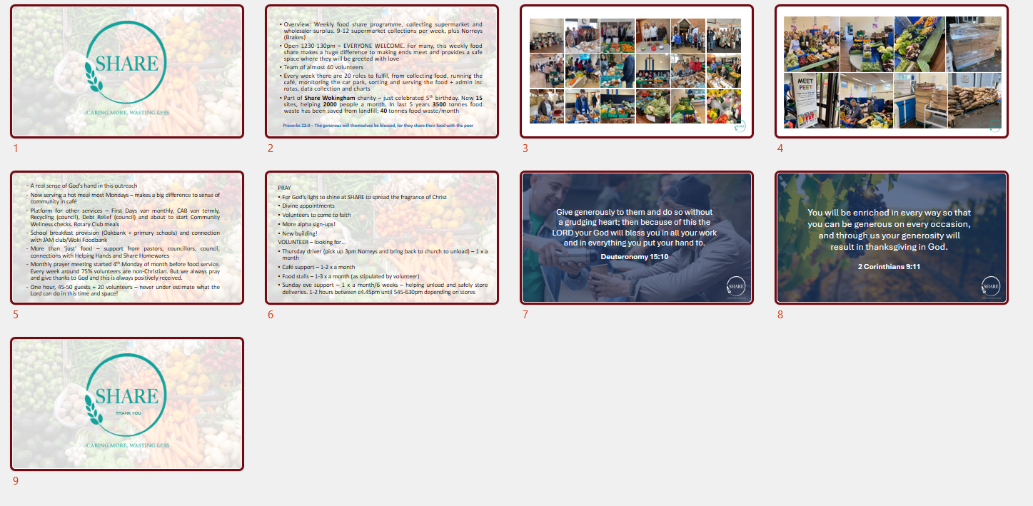
Share Presentation
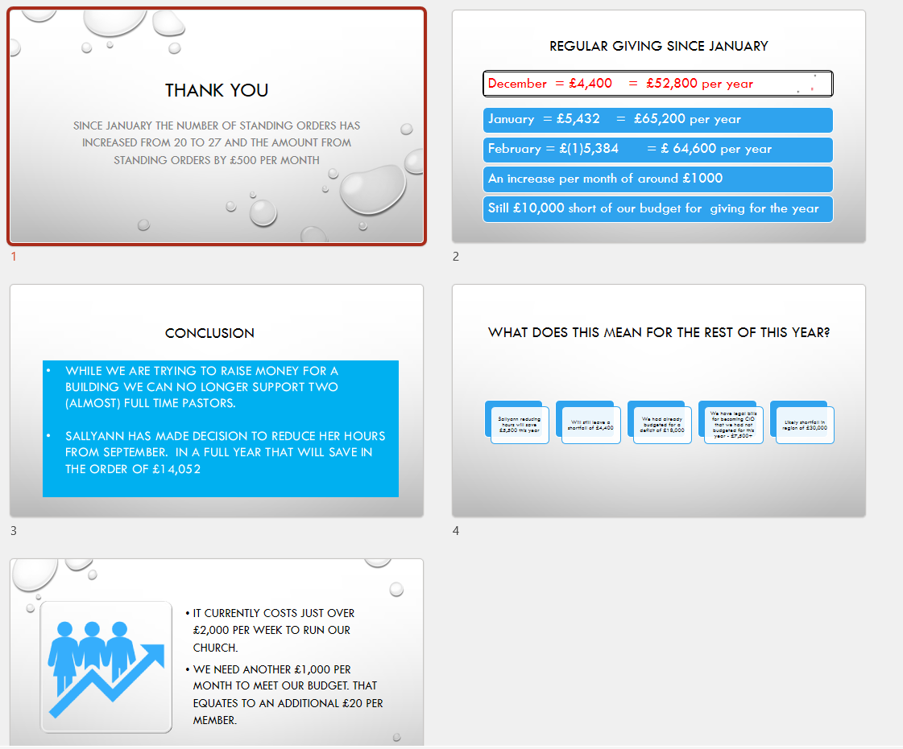
Finance Presentation

